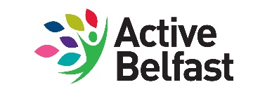

Decision Making Events - Successful Projects
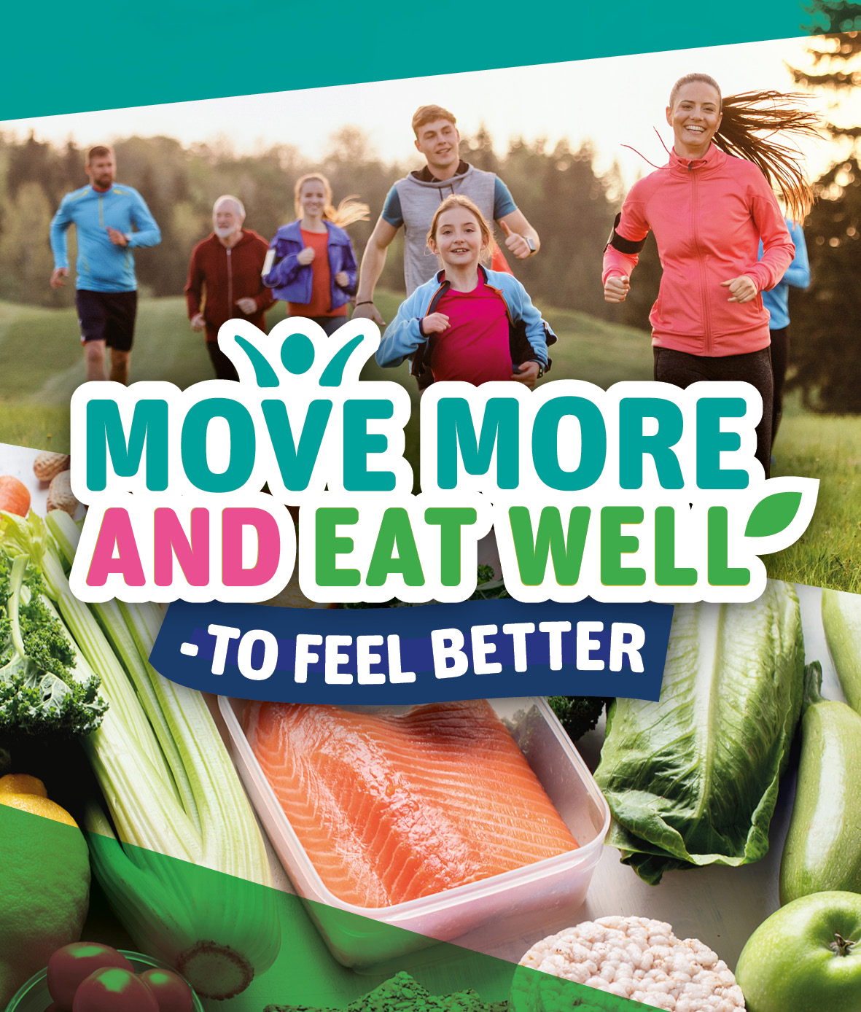

West Belfast
Group | Cullingtree Meadows
Project | Cullingtree Meadows
About the project | Cullingtree Meadows is a supported living scheme for people living with dementia. To support our tenants to move more and live well by participating in armchair aerobics and to make home cooked meals for our tenants, bringing them into a communal meal.
Group | Clonard Neighborhood Development Partnership
Project | Clonard House- Steady Steps
About the project | This project is focusing on our older peoples population in the area. Post covid there has been an increase in the number of people who are socially isolated in our local area. There is a decrease in any physical activity in this age range which has had a major impact on mental wellbeing. This 12 weeks program will incorporate sessions such as Pilates, seated chair based exercise and dance classes.
Group | Bog Meadows Butterfly Group
Project | Bog Meadows Butterfly Group
About the project | To create a wildlife friendly garden that serves as a model for people to replicate in their own gardens, to grow food that will benefit both wildlife and people, to create a different habitat to the wetland in the nature reserve, and improve urban biodiversity. The group will do gardening activity to show case wildlife gardening, create a more sustainable outdoor space to run workshops and group activities, and provide an additional enriching and beautiful space for people to enjoy and benefit from being outdoors in nature. The garden would be visible, educational and inviting to new participants as well as providing space for creative work and social activities. This is great for both physical and mental health. It will create an improved sense of ownership and lead to further ideas for more creative uses in the space from those taking part.
Group | Lagmore Community Forum
Project | The Grow and Grub project
About the project | The Grow and Grub project will enhance the services already offered in Lagmore Forum Centre by offering a space where residents can come and learn horticulture skills and grow healthy fruit and vegetables and learn how to make a healthy meal using the produce. Participants will have a welcoming space to socialise and connect and make new friends. Through gardening the group will learn practical mindfulness skills that helps improve mental health and wellbeing and builds resilience.
Group | The Weatherbies
Project | Fun Topics with the Weatherbies - Good Food
About the project | Irish language project for children (early years/foundation key stage 1&2) which aims to create and deliver new animated and interactive educational resources on healthy eating and the natural environment in a fun and entertaining way. This will be used in communities centres, homes & schools to equip them with the right food choices, to feel better mentally and physically. The wider community will benefit because parents and grandparents will have 'round the dinner table' discussions with their children and use the resources the children will take home to further educate them. Inspire healthy eating conversations, within schools & homes, that they can make small but important change to them personally.
Group | Upper Andersonstown Women's Group
Project | When you know better you do better
About the project | A women's capacity building programme over an eight week period. Four weeks looking at and learning about mental health, the stress response, managing anxiety and depression and mindful resilience. Running through all these sessions the women will learn about the gut brain connection and the food mood link. The women will be able to create food lists and recipes using the foods they identify as helpful and good for mental health. Four weeks will be spent learning photography techniques and going around the local parks, with qualified walk leaders and taking photographs, resulting in an exhibition of the women's photography.
Group | Lagmore young men's group
Project | The Pizza Pod
About the project | Young mens project in Lagmore to encourage healthy lifestyles through physical activity and nutrition education, to beautify and improve our local area through environmental clean-up and community engagement, and to foster community spirit by creating an outdoor pizza station and social area where, local residents can gather and socialize. We believe that our "Move More & Eat Well" initiative will make a positive impact in our community by promoting healthy living and community engagement.
Group | Whiterock Children’s Centre
Project | its ALL about ME- dance, exercise and relax
About the project | The project aims to connect with local families and integrate Black and Minority Ethnic, asylum seeking and refugee families settling in west Belfast, as well as encouraging all those who participate to move more through exercise and dance as well as heightening ways of helping them to relax.
Group | Whiterock Children’s Centre
Project | its ALL about ME- create, cook and educate
About the project | The project aims to connect with local families and integrate Black and Minority Ethnic, asylum seeking and refugee families settling in west Belfast, as well as encouraging all those who participate to eat well to feel better through creating a diverse range of dishes, in the most healthy and inexpensive way possible as well as heightening awareness of substitutes in meals, healthier options, other ways of cooking eg slow cooker, air fryer, as well as helping to educate families about alternative dishes and healthier options.
South Belfast
Group | iASSIST NI
Project | LIVING WELL KEEPING FIT
About the project | Families and individuals from the BAME, asylum seeker, refugee and new comer communities project. The project will focus mainly on teaching and encouraging families and individuals to eat healthy through Nutrition and well being sessions, through activities and exercises to keep fit and staying healthy.
Group | Open Ormeau Community Collective
Project | Ballynafit
About the project | Outdoor sports day/healthy eating event in the local area, where participants come and try new activities and participate in fun races. Participants will be provided with healthy snacks and recipe cards, and encouraged to sign up to Facebook healthy eating community to continue to share healthy recipes and participate in healthy eating classes.
Group | St Michael's Primary School
Project | Outdoor Classroom
About the project | Development of outdoor classroom for pupils to work outdoors, grow seeds and plants, investigate and find out about the local environment. This area requires resources such as gardening equipment, plants, seeds, soil and growing pots.
Group | Step with Annette
Project | Couch to Ceili
About the project | Couch to Céilí - fun guaranteed - get moving - get dancing! For beginners of all ages and abilities. Promoting a mix of Irish Ceili, Scottish, French and Breton dances to cater for the cross community.
Group | Green Summer Group
Project | Green Summer Project
About the project | Women's healthy eating and physical activity project for asylum seekers and refugees to stay healthy, be fit, have fun, eat well and be healthy for summer. Will include 2 get togethers to eat together and a 4 week walking programme to move together.

North Belfast
Group | Inspire Wellbeing & Choice Housing Association
Project | Peters Hill Green Space
About the project | Transform ground into a “greenspace”giving the people in supported living their own space for gardening, allowing them to gain new skills and have a sense of achievement about the space they have worked in. The space will also be used to play games, carry out fitness activities, as well as host activities for people from other Inspire Schemes.
Group | Ligoniel Womens Group
Project | Ligoniel Slow Cooker Programme
About the project | Healthy Eating 6 week project for womens group in Ligoniel on the benefits and uses of a slow cooker.
Group | Shankill Womens Centre
Project | Rave In The Wave
About the project | “Rave in the Wave” Cross Community Aqua and Healthy Eating Women's programme in Shankill Leisure Centre. Carryout exercise routines in the water for all age ranges and will provide a healthy meal for each participant with a Halo Healthy Kitchen facilitator to provide information on the importance of healthy eating.
Group | Cliftonville Community Regeneration Forum
Project | Manor Street Women's Group
About the project | Women's cross-community, multicultural Healthy Eating Programme to improve their cooking skills and to gain knowledge and confidence on healthy eating to produce more balanced and cost effective meals for themselves and their families using Air Fryers and Slow Cookers.
Group | Streetbeat Youth Project
Project | Volunteer programme- Duke of Edinburgh Award
About the project | Take 5 - ‘Be active and learn a new skill’ to ‘empower young people 18-19 year olds; to support them as they learn new skills, overcome obstacles, and build confidence and resilience.’ Working to achieve the Duke of Edinburgh award the participants must complete a physical activity within their community at least once a week for 3 months for as little as 1 hour per week. The participants then complete an active expedition were they will track the Mourne Mountains in Newcastle as a team, using their skills gained and improved fitness levels.
Group | Community Foodbank
Project | Healthy cooking schools sessions
About the project | Primary and post primary schools programme on healthy eating to reduce childhood obesity, enhance healthy eating long term habits and co-produce into physical activities. The project will provide sessions on the importance of a healthy dietary intake, food groups and the benefits of these groups and provide children with additional lifeskills to actually cook a meal and break down the costings.
Group | Belfast Mindful Walkers
Project | Mindful Walking Picnics
About the project | 3 mindful walks and picnics with members of the asylum & refugee community to enable them to participate in truly getting the opportunity to be present, to see the beauty around them and to benefit mentally. The picnic element provides opportunity for people to experience mindful eating as part of the activities.
Group | Star Neighbourhood Centre
Project | Young Women's Sports Skills
About the project | 10 week physical activity programme for young girls aged 11-14 to learn the life skills needed to make healthier choices and become more involved in regular exercise.
Group | Reach Out
Project | Reach Out Mums
About the project | 6 week physical activity and nutrition programme for mums/carers in north Belfast to improve their mental and physical health and knowledge of a healthy balance diet.

East Belfast
Group | Lagan Village Youth and Community Group
Project | Shake it off and be healthy
About the project | A physical activity and healthy eating programme that can cater for those people who find it difficult to move and need to ease into a healthy exercise programme. The exercise equipment for the project will cater for those who are obese, overweight, have mobility issues and those who need to get back into having a healthier lifestyle. This programme will help to address those issues and more by having the equipment and the facilities to promote a healthy living programme.
Group | EastSide Greenways
Project | Get moving on the Greenway
About the project | This two part programme is designed for local children and adults alike. Join one of our events over three weeks to get people more active through dance, fitness, sports and using the Connswater Community Greenway for walking and cycling. Healthy snacks will be provided.
Group | Monday Well being Group
Project | Parents and children moving together
About the project | Our project will bring parents and children together to improve both physical health and mental health in a programme of light exercise at our community hub at Nettlefield Multi- Sports. Through our project we will format a programme of an exercise programme for both adults and children separately then combine both in an exercise programme involving parents and children in games and exercise routines.
Group | East Belfast Mission
Project | Dancing through the ages
About the project | Intergenerational dance programme which includes 4 x 1hr sessions based around themes linked with the decades/eras of dance (Tea Dance 50s, Grease 60s, Disco Dancing 90s, Clubbercise 00s+). We want to encourage all generations in the family to take part, joining old & young together. We want to recreate the 'Dance Hall' socials, encouraging those who feel isolated to come out and socialise to create new memories. The dance sessions will be for all ages to take part, no matter their capability. A silent Disco week, will be suitable for those with ASD.

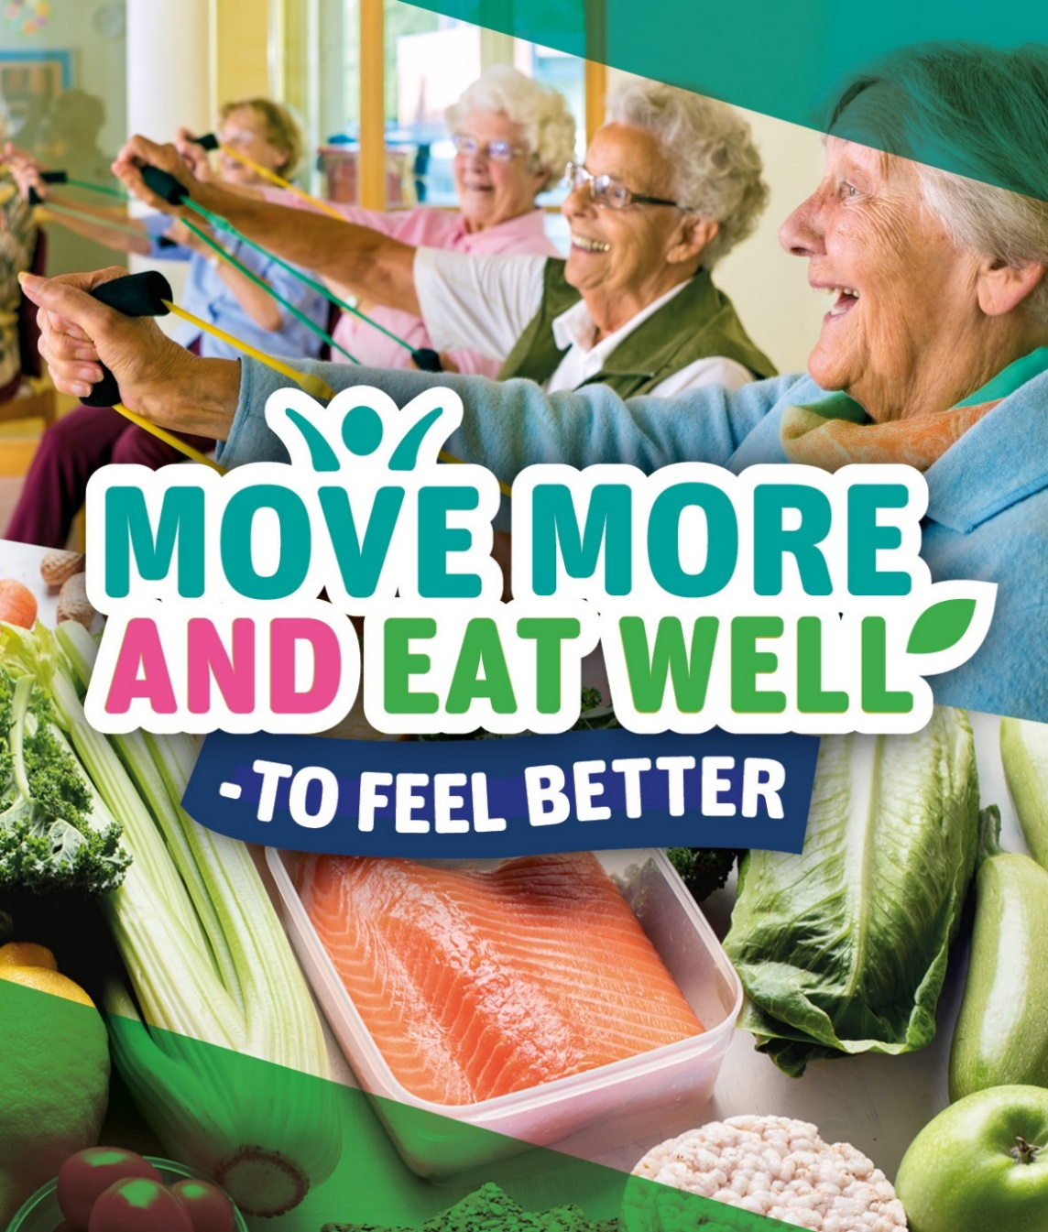
For further information on the work of Active Belfast please contact:

Belfast Health Development Unit
3rd Floor North
Cecil Ward Building
4-10 Linenhall Street
Belfast
BT2 8BP

E: mlbt@bhdu.org
Or visit: www.makinglifebettertogether.com

