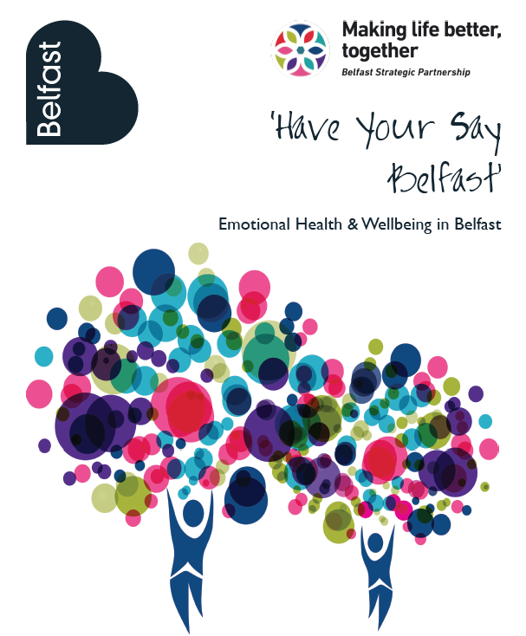

### Introduction:

This document presents a summary of the results of the second ‘Have Your Say Belfast’ survey which was issued as part of an ongoing process for emotional resilience in Belfast.

Belfast Strategic Partnership’s[1] Mental Health and Emotional Wellbeing (MHEW) thematic group published a 3 year strategy for development of emotional resilience in the Belfast area in 2014. This survey is the second in a series of surveys providing an insight into the emotional health and wellbeing of residents in the Belfast City Council Area. The following analysis is based on completed returns from 4,934 residents[2].

### Demographic Profile:

* Just over 60% of respondents were female, 39% male and less than 1% transgender.
* More than 50% of respondents were over 51 years of age, with just less than 14% under 18 years of age.
* 40% of respondents indicated that they were employed, just over 30% retired, 8% unemployed and just under 17% were students or attending school.
* 21% of respondents indicated that they have a disability.
* 92% of respondents indicated that they identify as heterosexual with just over 4% indicating that they identify as lesbian/gay or transgender.
* 30% of responses were received from residents living in the Top 20% most deprived Super Output Areas in Belfast.

### Personal Experience Treatment for Anxiety/Depression:

More than 27% of respondents indicated that they had treatment for anxiety or depression in the 12 months preceding completion of the questionnaire (this is the same percentage reported in the 2012 survey).

* 31% of female respondents reported having received treatment for anxiety or depression compared to just over 20% of male respondents. Almost 38% of transgender respondents indicated that they had received treatment for anxiety or depression (*although the sample size for this is very small so care should be taken in reporting the percentages*).
* Just over 25% of people aged 51 or over and just over 15% of people aged 18 indicated that they had received treatment for anxiety or depression.
* 50% of respondents who considered themselves to have a **disability** indicated that they had received treatment for anxiety or depression (53% in 2012 survey).
* A higher percentage of people who identified as **gay or lesbian** indicated that they had received treatment for anxiety or depression in the year preceding the consultation. More than 44% indicated they had received treatment compared to 27% of people who identified as heterosexual (42% in 2012 survey).
* A higher proportion of people living in the **Top 20% most deprived areas** indicated that they had received treatment for anxiety or depression than those living in other areas throughout Belfast at just under 35% compared to 24% (36.2% compared to 24.3% in 2012 survey). Looking in more detail at this area-based figure, for those living in the Top 20% in each Assembly area in the city, the percentage breaks down at:
  + Living in Top 20% in East Belfast – 37%
  + Living in Top 20% in North Belfast – 37%
  + Living in Top 20% in South Belfast - 43%
  + Living in Top 20% in West Belfast – 30%
* 55% of those who indicated that their health had been affected by the Troubles/Conflict had received treatment for anxiety or depression in the 12 months preceding their response compared to 21% whose health had not been affected. We do not have comparable figures for the 2012 survey. We asked respondents to indicate how their health had been affected by the troubles/conflict – i.e., psychologically, physically or both. Of those who answered this question, the figures below highlight the percentage of respondents that have received treatment for anxiety or depression:
  + Psychologically affected – 51%
  + Physically affected – 35%
  + Affected both psychologically and physically – 68%
  + Many people outlined how they had been affected by the troubles and conflict ranging from a high proportion saying ‘we have all been affected in some way’, to those outlining very personal stories of how they had been affected including both personally involved in or witnessing shootings, bombings, having been held hostage, been a prison officer, member of armed forces or paramilitary etc.
* Less than 6% of respondents under 18 years of age, and just over 7% of 18-25 year olds indicated that their health had been impacted by the troubles/conflict.

### Impact of Social Connections:

More than 42% of respondents indicated that they get together with friends every day and more than 71% said once per week (30% and 40% respectively in 2012 survey).

More than 57% said they got together with family members every day and more than 28% once per week (46% and 30% respectively in 2012).

The charts below highlight the inverse correlation between the frequency with which people connected with friends and family and the proportion who had received treatment for anxiety or depression in the 12 months preceding the research:

|  |  |
| --- | --- |
| **Connections with FRIENDS:** | **Connections with FAMILY:** |
|  |  |

The charts show that just over 15% of those who are in contact with friends on a daily basis have received treatment for anxiety or depression, compared to almost 62% of those who said they don’t bother connecting with friends. In terms of connections to family members, the percentage is just under 25% of those who connect on a daily basis compared to almost 55% of those who don’t bother connecting.

### Involvement in community/social networks:

The chart below highlights that the percentage of respondents who had been treated by anxiety and depression who are involved in social networks. The chart shows that those who are involved in a club, volunteers or indicate that they have a good social life, were less likely to have been treated for anxiety and depression in the 12 months prior to completing the survey. The differential between those who indicated they had/had not a good social life was particularly marked.

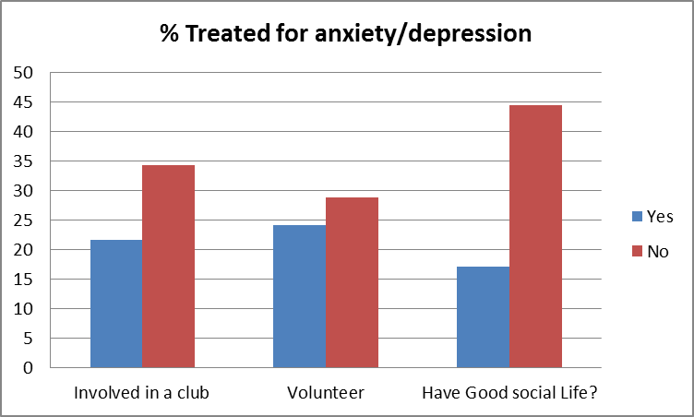

### Community change/Civic Pride:

Similar to the findings of the 2012 survey, people in Belfast generally feel that Belfast as a city has ‘got better’ over the past three years (53% - 55% in 2014 survey), however a lower percentage of respondents (28% - 24% in 2012 survey) feel that this is reflected in their own community. The reverse is true when we look at people’s perceptions of whether or not their area has ‘stayed the same’ over the past three years – 46% felt their community has stayed the same while 27% believe Belfast as a city has stayed the same. Interestingly, just over 35% of respondents under the age of 18 think that Belfast has ‘got better’.

This general feeling is reflected in each area of the city, with generally higher percentage of residents in east Belfast believing their area has improved (35% of residents compared to approximately 25% in each of the other areas of the city) although the chart below shows significant differences in the east and south of the city for those living in the Top 20% deprived areas:

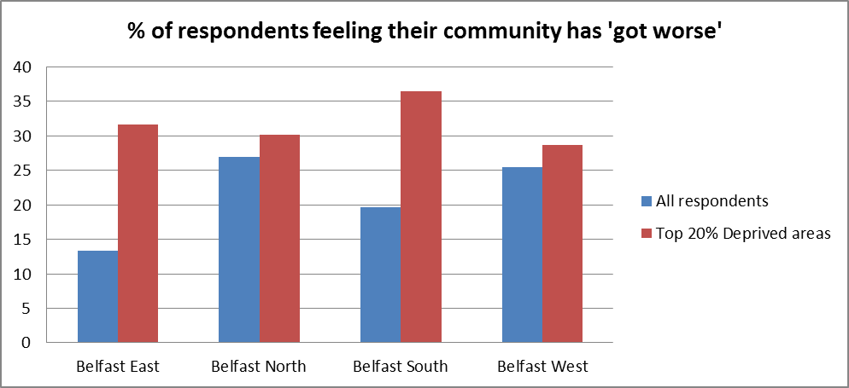

### Age specific findings:

### People aged over 51 years of age:

* 2,597 respondents over age - 52% female
* 25.5% treated for anxiety or depression in year prior to survey
* 25% said their health had been affected by the troubles
* 57% said they feel isolated (3.5% almost always, 6.5% most of the time, 10.6% half of the time. And 32.8% occasionally).
* 40% said they felt alone (3.6% almost always, 4.1% most of the time, 7.4% half of the time, and 21.7% occasionally).
* 58% are members of clubs
* 36% volunteer
* 62% say they believe they have a good social life
* 56% think Belfast has got better over the past three years
* 26% think their community has got better over the past three years.

### People age under 18:

* 678 respondents under 18 years of age
* Just over 15% treated for anxiety or depression in year prior to survey
* Less than 6% said their health had been affected by the troubles
* More than 64% are members of a club
* Less than 37% volunteer
* More than 82% believe they have a good social life
* More than 35% think Belfast has got better over the past three years
* 26% think their community has got better over the past three years.

### Issues important for improving Quality of Life:

The table below highlights in orders of importance the issues that respondents feel are most important in helping them to improve their quality of life:

|  |  |
| --- | --- |
|  | **Percentage of respondents** |
| Lower levels of Anti-Social behaviour | 37 |
| Better employment opportunities | 32 |
| Cleaner streets | 32 |
| Better community relations | 31 |
| Activities for children | 28 |
| Youth Health and Wellbeing Programmes | 27 |
| Improved parks and open space | 26 |
| More activities for older people | 26 |
| More community activities | 26 |
| Lower levels of Crime | 25 |
| More Arts and Cultural facilities | 23 |
| Support for community services | 20 |
| Access to affordable and decent housing | 19 |
| More Cafes (non-alcohol alternatives) | 18 |
| Parents support | 17 |
| More Sports/Leisure Facilities | 16 |
| Improved Sports/Leisure Facilities | 16 |
| More children’s Facilities | 13 |

As in the previous survey, the impact of anti-social behaviour is evident from the responses with the largest proportion of respondents indicating that a reduction in ASB would help improve their quality of life. Access to better employment opportunities was the second highest priority, similar again to the previous survey. The table above shows the need for multi-agency working to help address the issues impacting on the quality of life of residents throughout the Belfast City Council Area.

1. Belfast Strategic Partnership is a multi-sectoral Partnership established to identify and tackle life inequalities throughout the Belfast City Council Area. It is comprised of senior members of statutory, community and private sector organisations throughout the Belfast City Council Area.
2. Incomplete and duplicate returns have been removed for the analysis.