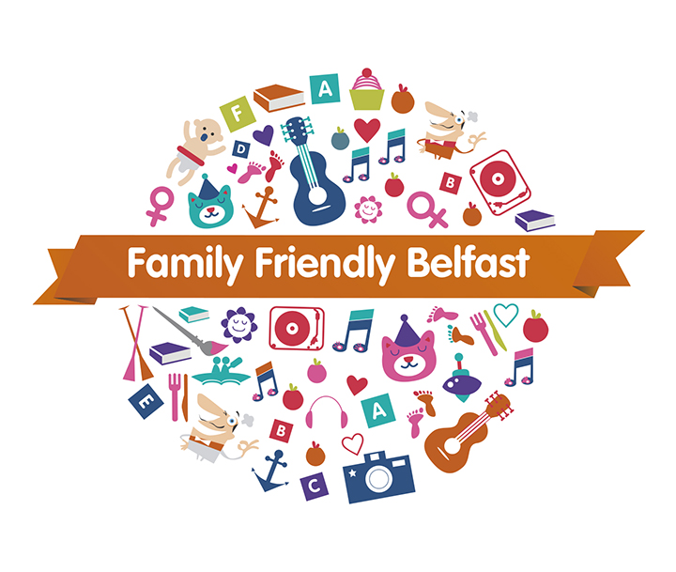

**To link in with the healthy food theme please see list of cafes and restaurants who are supporting Family Friendly Belfast 2015.**

|  |  |
| --- | --- |
| **Name of Business** | **Street** |
| **Café Wah** | **North Street** |
| **D&G's Bistro** | **Winetavern Street** |
| **Bagel Factory** | **CastleCourt** |
| **Coffee Avanzo** | **College Street** |
| **Allotment** | **Upper Queens Street** |
| **Spires Restaurant** | **Fisherwick Place** |
| **Pizza Jazz** | **12 Great Victoria Street** |
| **Flame Restaurant** | **46 Howard Street** |
| **Harlem Café** | **34 Bedford Street** |
| **Blinkers** | **1-5 Bridge Street** |
| **Mikeys Deli** | **Bridge Street** |
| **Dr B's Kitchen** | **9 Bridge Street** |
| **Brights Restaurant** | **High Street** |
| **Grapevine** | **Pottinger’s Entry** |
| **Spur Steak and Grill** | **Victoria Square** |
| **O'Briens** | **Victoria Square** |
| **O'Briens** | **CastleCourt** |
| **California Coffee** | **Arthur Street** |
| **Avoca Restaurant & Foodhall** | **41 Arthur Street** |
| **City Lite** | **44 Castle Street** |
| **Havana Bank Square** | **52 Berry Street** |
| **Debenhams Café** | **CastleCourt** |
| **Ground** | **Waterstones , Fountain Street** |
| **Ground** | **Next, Donegall Place** |
| **Belfast Tea and Coffee Company** | **107 Royal Avenue** |
| **The Greenhouse Café** | **9-15 Queen Street** |
| **Deli Lites** | **Rosemary Street/Lombard Street** |