Case Study 1
Mr B, is the main carer for his father who has dementia. His father is 75 years old.
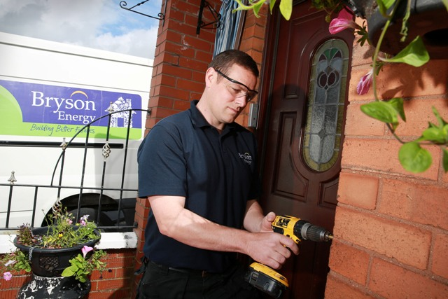
Mr B feels that his father’s conditioning is worsening and his eye sight is also deteriorating. “It’s a brilliant service that helps identify hazards that I wouldn’t have guessed that could be potentially dangerous to my father. The gentleman doing the assessment was very polite and helped show us how to use the aids and equipment correctly”

They were referred to the Belfast Home Safety Check & Repair service by NI Chest Heart & Stroke for a home safety check.

Case Study 2
Miss W, 69, lives alone in the Belfast Council Area. She lost her brother; she was his main carer, only a year ago to cancer.

“I try to do everything myself. But I have arthritis now, top to tail with it and I have no longer the power in my hands anymore. I contacted my landlord about fixing a lock and was told it would cost forty pound. Forty pound! I couldn’t afford that, it was only for two screws!

By luck I saw a flyer advertising the service at my local community centre and called call the free-phone number. Vincy, the handyman, called me back and arranged an appointment to call.
He was very friendly and polite. He was also a great worker and very tidy, which is important to me.

“It’s a marvellous service....and so important for people like me living on their own “

Miss W is registered disabled and was able to avail of the five pound an hour subsidised repair rate. The repairs included, fitting of a door bell, a door sign, a front door chain and installing a curtain pole. A free Home Safety Check was also completed. She had spotted a flyer at her local community centre.
