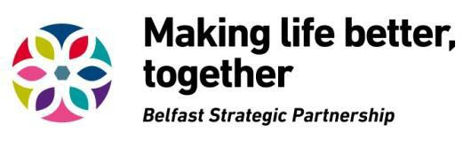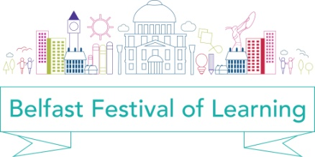

Be part of the
2017 Belfast Festival of Learning

Belfast Strategic Partnership’s Lifelong Learning Group would like to build on all the collaboration and creativity of the first Belfast Festival of Learning in 2016, and we invite you to be part of the 2017 Belfast Festival of Learning.

During the week of 20-26 March 2017 we are asking organisations to showcase a diverse range of learning opportunities in Belfast for people of all ages, all backgrounds and all locations. These may be already planned or you could plan one specifically for the festival.

We want to engage and re-engage Belfast citizens in learning and inspire interest and enjoyment, through a week long programme of interactive learning events and workshops. Once again, we particularly wish to showcase events that encourage the participation of groups and individuals who have experienced barriers in accessing learning opportunities.

We want to promote Belfast as a Learning City, a city that promotes lifelong learning for all.

Submit an idea for an event!

We want to enable as wide a range of organisations as possible to contribute to shaping the programme, and meeting the different needs of learners in the city, by directly creating and delivering events. We will look at every idea submitted with a view to endorsing it under the Belfast Festival of Learning, and we will co-ordinate and promote a citywide programme of events for the festival.

All you have to do is complete the attached Event Submission Form and send us your ideas by 5.00pm on 21 October 2016.

What are we looking for?

People learn for a variety of reasons; we have adopted a wide interpretation of learning from the EU definition that learning is “…undertaken throughout life with the aim of improving knowledge, skills and competence within a personal, civic, social and/or employment related perspective”

We encourage submissions for imaginative and creative events that build a programme that reflects and promotes the many reasons people have for learning, whether it is learning for, and in, work, learning to understand others and live together, learning skills or learning to deal with life’s challenges.

Who can apply?

We welcome ideas from a wide range of contributors including individuals and organisations such as community groups, schools and colleges, arts organisations, businesses, public bodies and cultural groups.

Events must reflect the aims of the festival which are:

- To promote learning in all its forms and promote Belfast as a Learning

City for all

- To engage learners of all ages in a wide range of settings across the city with a variety of learning opportunities
- To raise awareness of the engaging, fun and surprising ways we can

learn

The BSP Lifelong Learning Thematic Group will consider requests for financial support where no available funding exists to support a proposed event. This financial support is limited, and as we wish to support as broad a range of events as possible, we will consider support up to a maximum of £500 per event; requests will only be considered for one-off costs including venue hire, transport for learners, promotion of events, hospitality and logistical support for running events. Please list details of your request for financial support on the Event Submission Form.

In addition, BSP’s Family Friendly Belfast Initiative is offering financial support up to £500 per event within the Belfast Festival of Learning, which meet the following additional criteria:

• Events/activities that promote fun based learning activities aimed at families
• Events/activities that encourage families to try out new activities

together

In the Event Submission Form there is a specific Family Friendly events tick box. Please tick to apply for Family Friendly event funding.

What should you bear in mind?

Festival events have to be engaging and accessible for the wider community. If you are currently planning an event for this week which ties in with the aims and ethos of the Festival of Learning, we can help you promote your event as part of the festival programme.

How do you get involved?

We have an open response method, asking that you complete the Event Submission Form. Your submission will be considered alongside other ideas at festival programming meetings. A panel will meet to finalise the programme and make decisions on funding support for events and final decisions will be made by the end of October 2016 after which we will notify you of the panel’s decision.

Guidelines for festival events

• All events must take place within Belfast during the week of March 20-26 2017

• Events should be fully accessible and every effort should be made to cater for the special needs of attendees
• Events should be as creative and imaginative as possible with an emphasis on interactive learning
• Event organisers must take responsibility for all relevant insurances, licenses and health & safety requirements

- The support of event organisers in publicising and promoting their particular event(s), and the festival as a whole, on any print materials, social media and websites available would be appreciated
- We will provide feedback and evaluation processes for use at each event and your responses will be collated into an evaluation report.

More information

If you would like more information on any aspect of the Belfast Festival of Learning, please email Dolores Atkinson at dolores.atkinson@bhdu.org or telephone 028 9050
2073.

Please click on the following link to access “Belfast a Learning City” and the

Learning Charter.

www.makinglifebettertogether.com/lifelong-learning/

