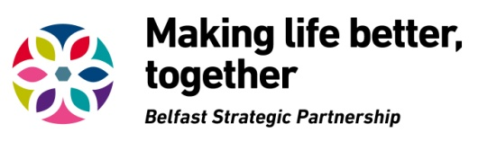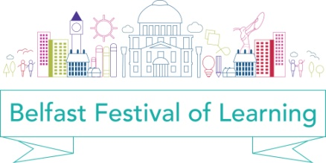

2017 Belfast Festival of Learning
Event Submission Form

Your details
Name:
Organisation (if applicable):

Address:
(including postcode)

Telephone number:
Email address:
Website address:
What type of organisation/group are you? (select one)
Social Enterprise
Unregistered charity, club, society, association, community based group or organisation
Organisation recognised by HRM Revenue & Customs as charitable for tax purposes
Charity registered with Charity Commission NI
Charity registered in England, Wales or Scotland
Educational establishment
Statutory organisation
Other (please state)

Event details
Event title:

Event date/s (dd/mm/yyyy): |  | Start Time: | End Time:
Location/venue for your event:

Event description (max 100 words):
These details will be used for the Festival Events Guide, (please include details of contact person, tel number, email address, if different from details above).

Are you targeting any particular group or age range? If so, please give details:

How will learners benefit from your event?

How many learners will benefit from your event?

Do you require financial support?
If yes, please complete details below (max £500)
Are you applying for funding under (select one)
Lifelong Learning

Family Friendly
List each item you require financial support for | Breakdown of costs
Total applied for

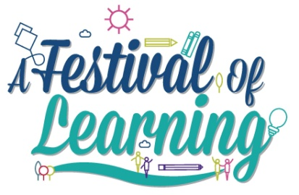 | Please return completed forms to:  Dolores Atkinson, Project Development Outreach Officer at  dolores.atkinson@bhdu.org

Please complete and return by 5.00pm on Friday 21 October 2016.

For more information on Belfast Strategic Partnership and the Lifelong Learning Thematic group, please visit our website: www.makinglifebettertogether.com

