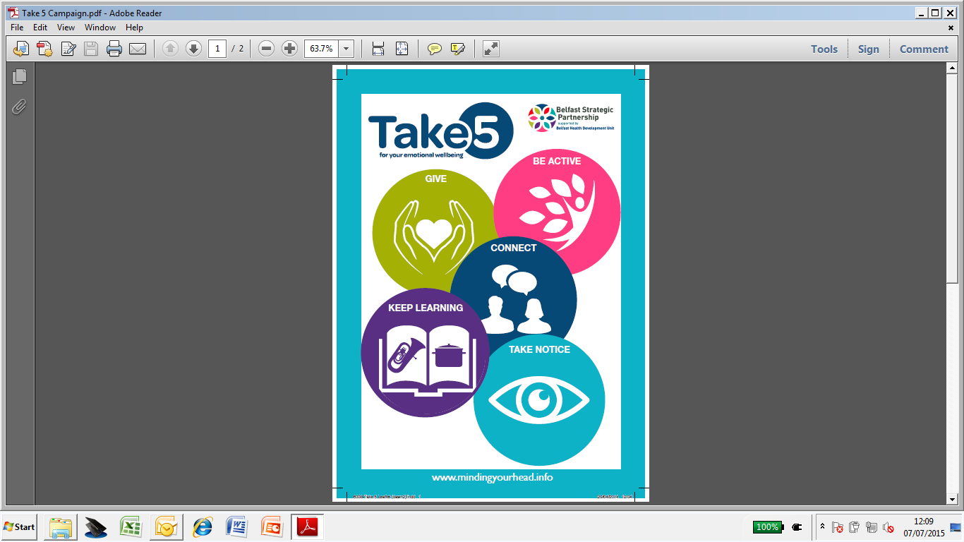

**BE ACTIVE**

**GIVE**

**WHAT IS HAPPENING IN YOUR AREA**

**Men’s and Women’s Fitness Boot camps and Seniors Functional Fitness Programmes**

Shaftesbury Recreation Centre – Contact Camilla Reynolds on 028 90 312 377

Fit for Life Centre, Donegal Road – Contact Glen McCrum on 028 90 333 527

Chinese Welfare Association – Contact Marina Pojoga on 028 90 288 277

Ballynafeigh Community Association – Contact Darren Spence on 028 90 491 191

**Volunteer Now** –Contact on 028 9023 2020 or see www.**volunteernow**.co.uk

**Ballynafeigh Men’s Shed in Ormeau Park Bowling Pavillion** – Contact Darren Spence on 028 90 491 161

**Bingo** - Sandy Row Community Centre every Monday from 8pm-9.30pm– Contact Adrian Dalton on 028 90 325 403

**CONNECT**

**South Belfast Lifestyle Forum** – Meets every Tuesday at 11am in CRI Building, Donegal Pass – Contact Theresa McVeigh on 028 9073 5696

**Got It? Basic Introduction to Computers, Internet and Emails** – Ormeau Library – Contact Allison Milligan on 028 9050 9228

**Knit and Natter Group** – Meets every Thursday from 10am-12.30 in Ormeau Library - Contact Allison Milligan on 028 9050 9228

**TAKE NOTICE**

**KEEP LEARNING**

**Mindfulness Walks** – Contact Camilla Reynolds on 02890 312 377

**Photography Club** – Every Wednesday 7pm-10pm, Sandy Row Community Centre, Contact Adrian Dalton on 028 90 325 403

**Donegal Pass Community Garden Workshops** – Contact Anne McAllister on 02890 326 256

**Botanical Gardens Belfast**

**Ulster Museum Belfast -** nmni.com/um

**Cook It programmes**

Shaftesbury Recreation Centre – Contact Camilla Reynolds on 028 90 312 377

or

Fit for Life Centre, Donegal Road – Contact Glen McCrum on 028 90 333 527

**Words Alive** – Meets every Monday 9am-1pm Donegal Pass Community Centre

Contact

**Open Learning** – Queens University Belfast – [www.qub.ac.uk](http://www.qub.ac.uk)

**Lisburn Road and Ormeau Road Libraries**