[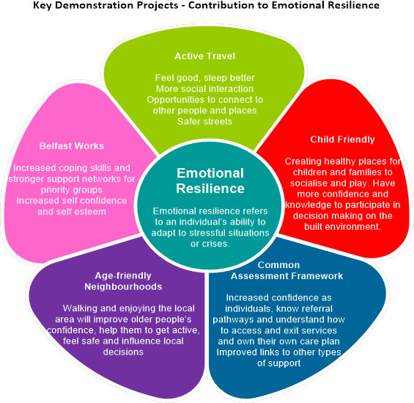](http://www.makinglifebettertogether.com/wp-content/uploads/2015/02/diagram1.jpg)