FRESH is a twice weekly, 12-week healthy lifestyle programme for overweight young people aged 11-14 years old who want to:

- Become more active
- Learn about a healthy lifestyle
- Get motivated and feel good about themselves
- Have fun and make new friends
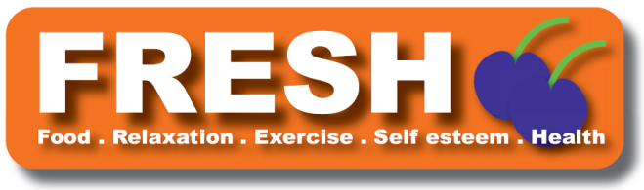

FRESH will take place after school on Tuesdays & Thursdays from September to December 2015 at:
Shankill Leisure Centre, 100 Shankill Road, Belfast

The programme is free and offers young people:
- 2 hours of fun physical activity each week
- Information on good food choices and changing behaviour
- information and support for parents
Get motivated -feel good !
Have fun and make friends
Learn about a healthy lifestyle

For more information or to register contact the FRESH Dietitians on:
 028 95 042317 or fresh@belfasttrust.hscni.net
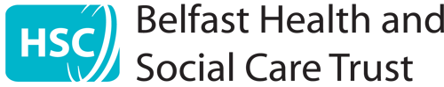
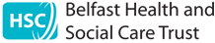
FRESH is funded by the Public Health Agency and is co-ordinated by Belfast Trust Community Nutrition and Dietetic Service in partnership with a range of other HSC Trust departments, local councils, Sport NI, Belfast Health Development Network, education and community organisations. It is delivered by Community Dietitians, School Nurses, Physical Activity coaches and Psychologists.

