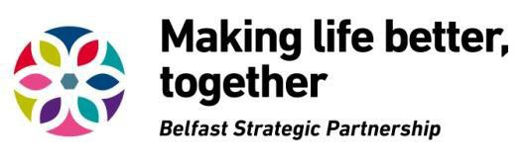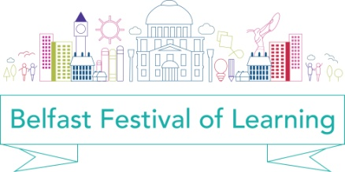

Be part of the
2018 Belfast Festival of Learning

Belfast Strategic Partnership’s Lifelong Learning Group invites you to be part of the 2018 Belfast Festival of Learning. An annual citywide festival of learning is a key part of our vision of building Belfast as a learning city under the UNESCO Global Network of Learning Cities.

During the week of 5-11 March 2018 we are asking organisations to showcase a diverse range of learning opportunities in Belfast for people of all ages, all backgrounds and all locations. These may be already planned or you could plan one specifically for the festival. We want to create an exciting inclusive programme of events which attracts everyone into learning!

Once again, we particularly wish to showcase events that encourage the participation of groups and individuals who have experienced barriers in accessing learning opportunities.

We want to promote Belfast as a Learning City for all.

Submit an idea for an event!

We want to support as wide a range of organisations as possible to help build the programme and meet the different needs of learners in the city by directly creating and delivering events. We will look at every idea submitted with a view to endorsing it under the Belfast Festival of Learning, and we will co-ordinate and promote a citywide programme of events for the festival.

All you have to do is complete the attached Event Submission Form and send us your ideas by 5.00pm on Monday October 23rd 2017.

What are we looking for?

We want submissions for imaginative and creative events that build a programme that reflects and promotes the many reasons people have for learning, whether it is learning for and in work, learning to understand others and live together, learning skills or learning to deal with life’s challenges.

Who can apply?

We welcome ideas from a wide range of contributors including individuals and organisations such as community groups, schools and colleges, arts organisations, businesses, public bodies and cultural groups.

Events must reflect the aims of the festival which are:

- To promote learning in all its forms and promote Belfast as a learning

city for all

- To engage learners of all ages in a wide range of settings across the city with a variety of learning opportunities
- To raise awareness of the engaging, fun and surprising ways we can

learn

The BSP Lifelong Learning Thematic Group will consider requests for financial support where no available funding exists to support a proposed event. This will be up to a maximum of £500 per event.

Requests will only be considered for one-off costs including venue hire, transport for learners, promotion of events, hospitality and logistical support for running events. Please list details of your request for financial support on the Event Submission Form.

Our financial support is very limited and we know it will only cover a small proportion of events. We would therefore welcome applications from organisations that could plan an event for this week, which ties in with our aims and ethos of making learning accessible and engaging for all, and which do not require financial support. This would help to extend the programme to as many people as possible in the city.

In addition, BSP’s Family Friendly Belfast initiative is offering financial support up to £500 per event within the Belfast Festival of Learning, which meet the following additional criteria:

• Events/activities that promote fun based learning activities aimed at families
• Events/activities that encourage families to try out new activities

together

In the Event Submission Form there is a specific Family Friendly events tick box. Please tick to apply for Family Friendly event funding.

What should you bear in mind?

Festival events have to be engaging and accessible for the wider community.

How do you get involved?

We have an open response method, asking that you complete the Event Submission Form. Your submission will be considered alongside other ideas at festival programming meetings. A panel will meet to finalise the programme and make decisions on funding support for events and final decisions will be made by the middle of November after which we will notify you of the panel’s decision.

Guidelines for festival events

• All events must take place within Belfast during the week of March 5-11 2018

• Events should be fully accessible and every effort should be made to cater for the special needs of attendees
• Events should be as creative and imaginative as possible with an emphasis on interactive learning
• Event organisers must take responsibility for all relevant insurances, licenses and health & safety requirements
- The support of event organisers in publicising and promoting their particular event(s), and the festival as a whole, on any print materials, social media and websites available would be appreciated
- We will provide feedback and evaluation processes for use at each event and your responses will be collated into an evaluation report.

More information

If you would like more information on any aspect of the Belfast Festival of Learning, please email Dolores Atkinson at dolores.atkinson@bhdu.org or telephone 028 9050
2073.

Please click on the following link to access “Belfast a Learning City” and the

Learning Charter.

www.makinglifebettertogether.com/lifelong-learning/

